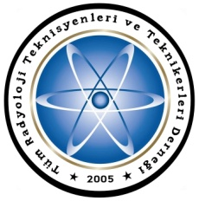
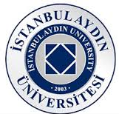

SYMPOSIUM OF MEDICAL IMAGING and RADIATION PROTECTION
April 13, 2014, Istanbul, TURKEY
08.30-09.30 Registration
09.30-10.00 Opening spech
Prof. Dr. Yadigar IZMIRLI/ Symposium honorary chairman
Prof.Dr. Bulent TEKINSOY / Symposium chairman
Heybet ASLANOGLU / President of TUMRAD-DER
Ayhan OZDEMIR / Radiology lecturer, DEU
1.SESSION
Chairman Hasan DURMUS, Radiology lecturer / Aydın University
10.00-10.30 Radiation protection Legislation of the European Union, like Euratom directives, and clinical audit.
Mr. Dimitris KATSIFARAKIS / ISRRT Director of Europe Region
10.30-11.00 Radiation protection Legislation of the European Union, like Euratom directives, and clinical audit.
Mr. Dimitris KATSIFARAKIS / ISRRT Director of Europe Region
11.00-11.20 Coffee break
2. SESSION
Chairman Ayhan OZDEMIR,Radiology lecturer, DEU
11.20-12.00 Smart card -smart tracking dose , a project of the Int. Atomic Energy agency.
Mr. Dimitris KATSİFARAKİS / ISRRT Director of Europe Region
12.00-12.30 How to communicate radiation risk to the patient
Dimitris KOUMARIANOS /
12.30-13.30 Lunch break and concert
3. SESSION
Chairman Bulent TEKINSOY MD, PROF. / Aydın University, Director of Radiology school
13.20-14.10 Optimization of the dose during CT.examination
Ersin KARCI / Siemens,Director of CT production
Murat KARAKOC / GE, Healthcare CT training specialist
14.10-14.40 Radiation production and dose control for intervention examitations
Prof. Dr. Mustafa DEMİR / İstanbul Üniversitesi Cerrahpaşa Tıp Fak.
14.40-15.10 Quality control on the radiography and dose effect of calibrations
Gurdogan AYDIN, Radiology lecturer/ Kapadokya University School of Radiology
15.10-15.30 Coffee break
4.SESSION
Chairman Gurdogan AYDIN/ Kapadokya Univ, School of Radiology.
15.35-16.00 Responsibility and duties of Radiation protection committee
Havva PALACI, Radiology lecturer / Gedik Univ.School of Radiology
16.00-16.25 Protection materials and using dosimeter
Heybet ASLANOGLU / President of TUMRAD-DER
16.25-16.50 Quastions -Answers
16.50-17.00 Closing

SYMPOSIUM HONANARY CHAIRMAN
Prof. Dr. Yadigar IZMIRLI/ İstanbul Aydin University, Rector
SYMPOSIUM CHAIRMAN
Prof. Dr. Bulent TEKINSOY / Istanbul Aydın University, Director of Radiology.
ORGANIZING COMMİTTEE
Hasan DURMUŞ, Radiology Lecturer / Istanbul Aydin University, School of Radiology
Huseyin Ozan TEKIN, Radiology Lecturer / Istanbul Aydin Univ. School of Radiology
Ayhan OZDEMIR, Radiology Lecturer, DEU School of Radiology
Heybet ASLANOGLU / President of TUMRAD-DER
Özer ERDEN / Board member TUMRAD-DER
Symposium Secreteriat
Tüm Radyoloji Teknisyenleri ve Teknikerleri Derneği
Millet Cad. No.11 İnan İşhanı K.6 / 615 Aksaray-Fatih / İSTANBUL
Tel & Fax : 0 212 530 30 23 Gsm: 0 505 920 13 13
www.tumrad.net tumradder@gmail.com

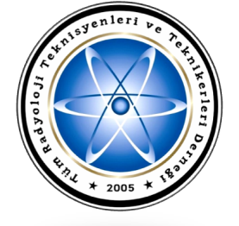
Tüm Radyoloji Teknisyenleri ve Teknikerleri Derneği
Millet Cad. No.11 İnan İşhanı K.6 / 615 Aksaray-Fatih / İSTANBUL
Tel & Fax : 0 212 530 30 23 Gsm: 0 532 292 46 27
www.tumrad.net tumradder@gmail.com
İstanbul Aydın Üniversitesi SHMYO
Beşyol Mah. İnönü Cad. No 38 Sefaköy-Küçükçekmece / İSTANBUL
Tel : 444 1 428 Fax: 0 212 425 57 59

